SE – OVERVIEW OF IT INDUSTRY.

- What is software? What is software engineering?
ANS. Software is a program or set of programs containing instructions that provide desired functionality.
Software Engineering is the process of designing, developing, testing, and maintaining software. It is a systematic and disciplined approach to software development that aims to create high-quality, reliable, and maintainable software.
- Explain types of software.
ANS.
1.System software:
System software is software that directly operates the computer hardware and provides the basic functionality to the users as well as to the other software to operate smoothly.
- Operating System
- Language Processor
- Device Driver
2. Application Software:
Software that performs special functions or provides functions that are much more than the basic operation of the computer is known as application software.
- General Purpose Software
- Customized Software
- Utility Software
- What is SDLC? Explain each phase of SDLC
ANS. The Software Development Life Cycle (SDLC) is a process used by software development organizations to plan, design, develop, test, deploy, and maintain software applications.
PHASE:
- Requirements gathering and analysis: This phase involves gathering information about the software requirements from stakeholders, such as customers, end-users, and business analysts.
- 2. Design: In this phase, the software design is created, which includes the overall architecture of the software, data structures, and interfaces. It has two steps:
High-level design (HLD): It gives the architecture of software products.
Low-level design (LLD): It describes how each and every feature in the product should work and every component.
- Implementation or coding: The design is then implemented in code, usually in several iterations, and this phase is also called as Development
4. Testing: The software is thoroughly tested to ensure that it meets the requirements and works correctly.

5. Deployment: After successful testing, The software is deployed to a production environment and made available to end-users.
6. Maintenance: This phase includes ongoing support, bug fixes, and updates to the software.
4. What is DFD? Create a DFD diagram on Flipkart
ANS. Flow Diagram (DFD) represents the flow of data within information systems. Data Flow Diagrams (DFD) provide a graphical representation of the data flow of a system that can be understood by both technical and non-technical users.
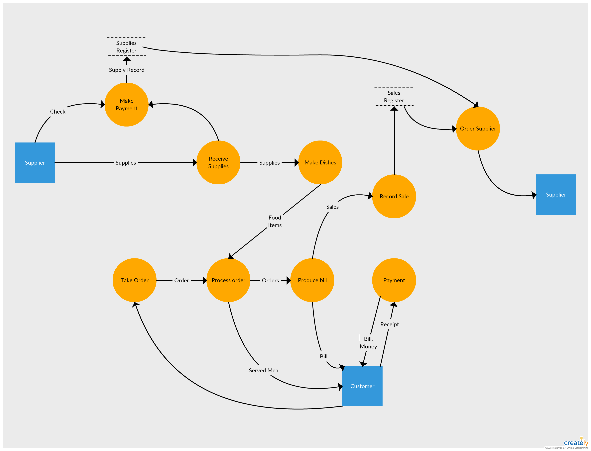

5. What is Flow chart? Create a flowchart to make addition of two numbers
ANS. A flowchart is a type of diagram that represents a workflow or process. A flowchart can also be defined as a diagrammatic representation of an algorithm, a step-by-step approach to solving a task.
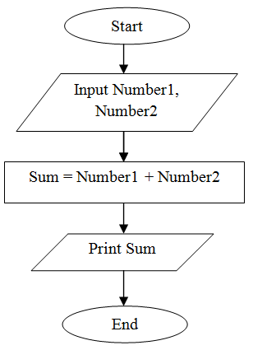

6. What is Use case Diagram? Create a use-case on bill payment on paytm.
ANS. Use Case Diagram is a type of Unified Modeling Language (UML) diagram that represents the interaction between actors (users or external systems) and a system under consideration to accomplish specific goals. It provides a high-level view of the system’s functionality by illustrating the various ways users can interact with it.
